Exercise Problems for Module 7
1. Draw an ERD containing the Order and Customer entity types connected by a 1-M relationship from Customer to Order. Choose an appropriate relationship name using your common knowledge of interactions between customers and orders. Define minimum cardinalities so that an order is optional for a customer and a customer is mandatory for an order. For the Customer entity type, add attributes CustNo (primary key), CustFirstName, CustLastName, CustStreet, CustCity, CustState, CustZip, and CustBal (balance). For the Order entity type, add attributes for the OrdNo (primary key), OrdDate, OrdName, OrdStreet, OrdCity, OrdState, and OrdZip. If you are using a data modeling tool that supports data type specification, choose appropriate data types for the attributes based on
your knowledge.
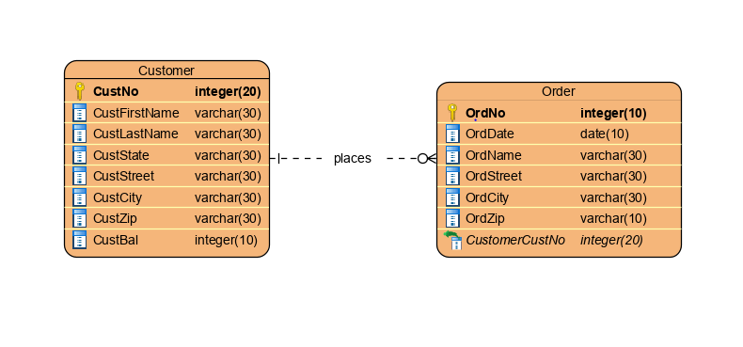

2.Extend the ERD from problem 1 with the Employee entity type and a 1-M relationship from Employee to Order. Choose an appropriate relationship name using your common knowledge of interactions between employees and orders. Define minimum cardinalities so that an employee is optional to an order and an order is optional to an employee. For the Employee entity type, add attributes EmpNo (primary key), EmpFirstName, EmpLastName, EmpPhone, EmpEmail, EmpCommRate (commission rate), and EmpDeptName. If you are using a data modeling tool that supports data type specification, choose appropriate data types for the attributes based on your common knowledge.
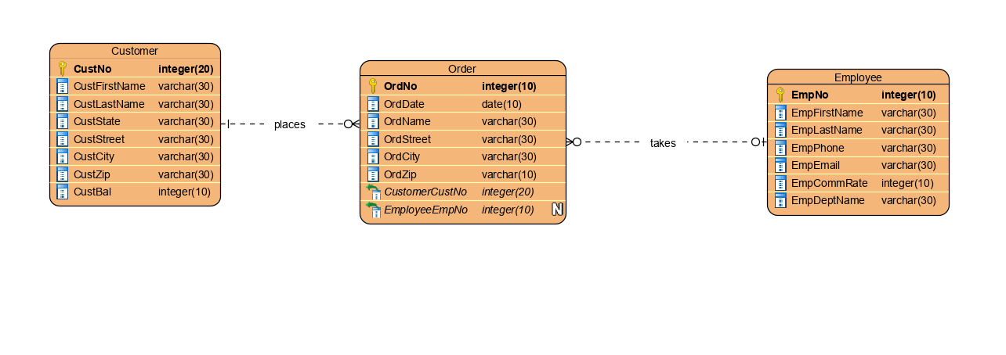

3. Extend the ERD from problem 2 with a self-referencing 1-M relationship involving the Employee entity type. Choose an appropriate relationship name using your common knowledge of organizational relationships among employees. Define minimum cardinalities so that the relationship is optional in both directions.
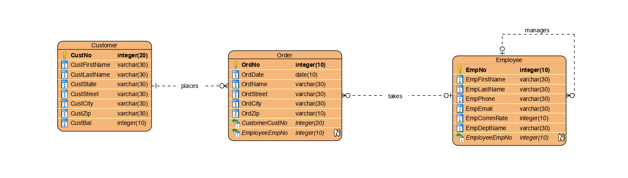

4. Extend the ERD from problem 3 with the Product entity type and an M-N relationship between Product and Order. Choose an appropriate relationship name using your common knowledge of connections between products and orders. Define minimum cardinalities so that an order is optional to a product, and a product is mandatory to an order. For the Product entity type, add attributes ProdNo (primary key), ProdName, ProdQOH, ProdPrice, and ProdNextShipDate. For the M-N relationship, add an attribute for the order quantity. If you are using a data modeling tool that supports data type specification, choose appropriate data types for the attributes based on your common knowledge.Revise the ERD from problem 4 by transforming the M-N relationship into an associative entity type and two identifying, 1-M relationships.

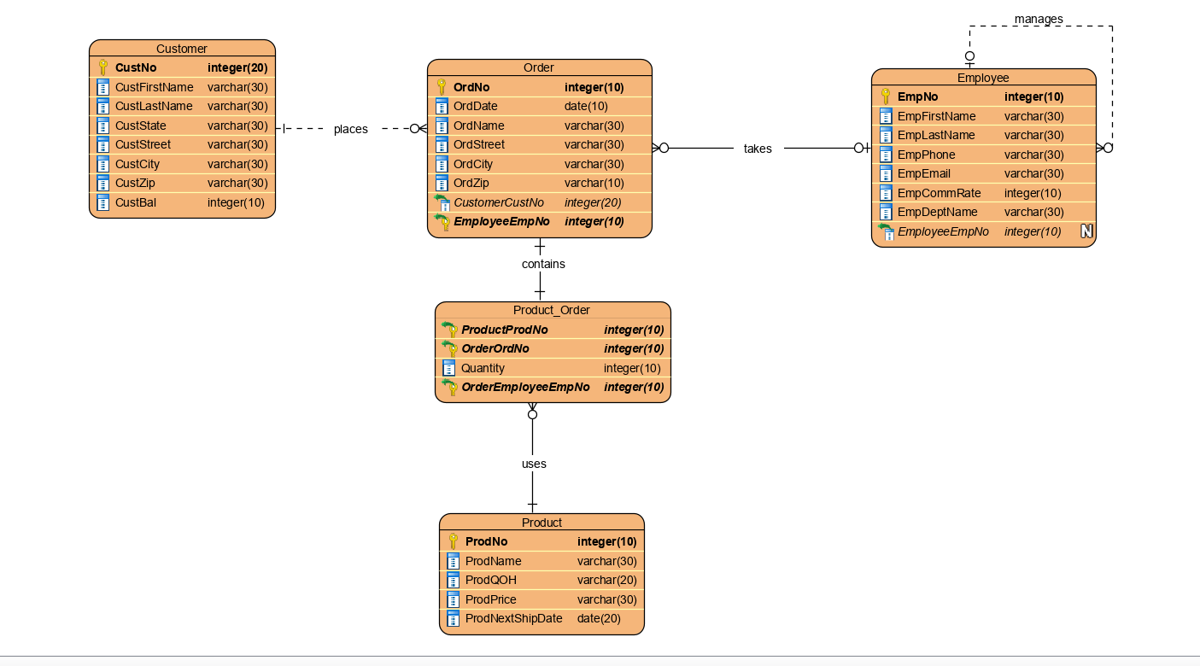

5..Using your ERD from problem 5, add violations of consistency rules for identification dependency (weak entity type rule, identifying relationship rule, and identification dependency cardinality rule) and redundant foreign keys (1 rule).

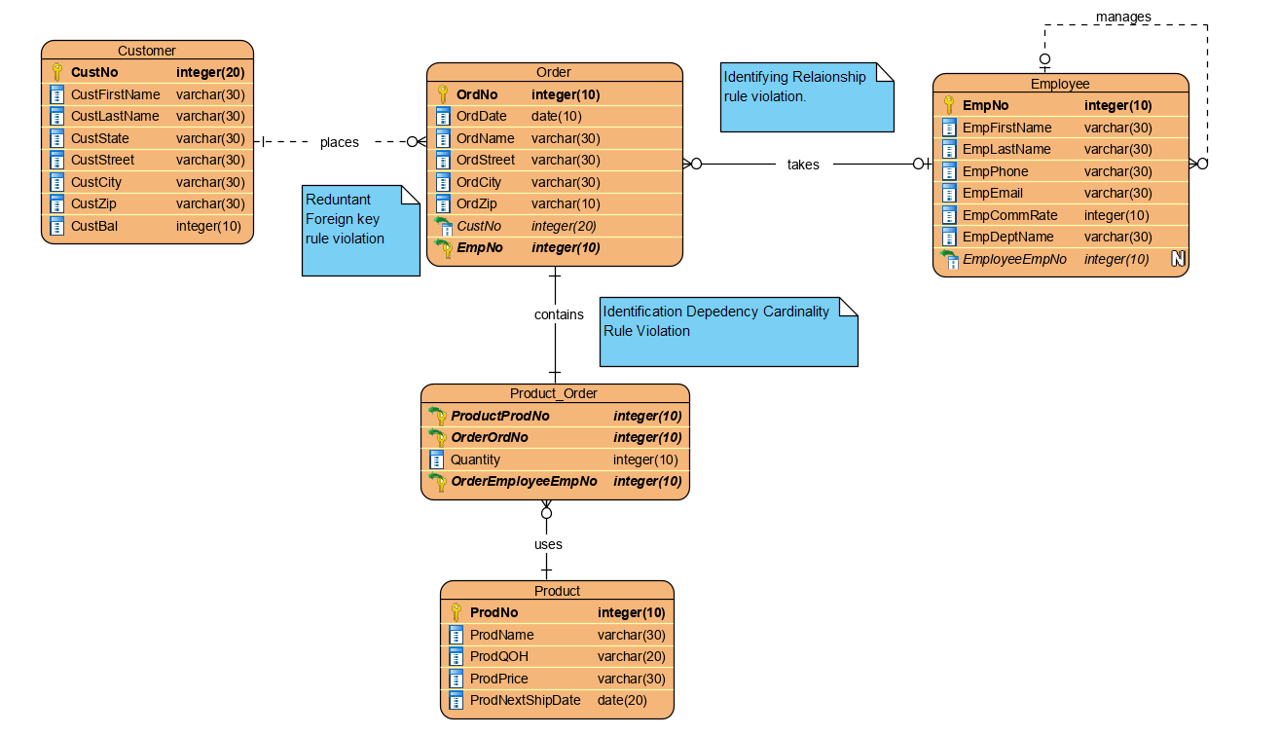

6.For each diagram error in Figure P7, identify the diagram rule violated and suggest possible resolutions of the error. The ERD has generic names so that you will concentrate on finding diagram errors rather than focusing on the meaning of the diagram.

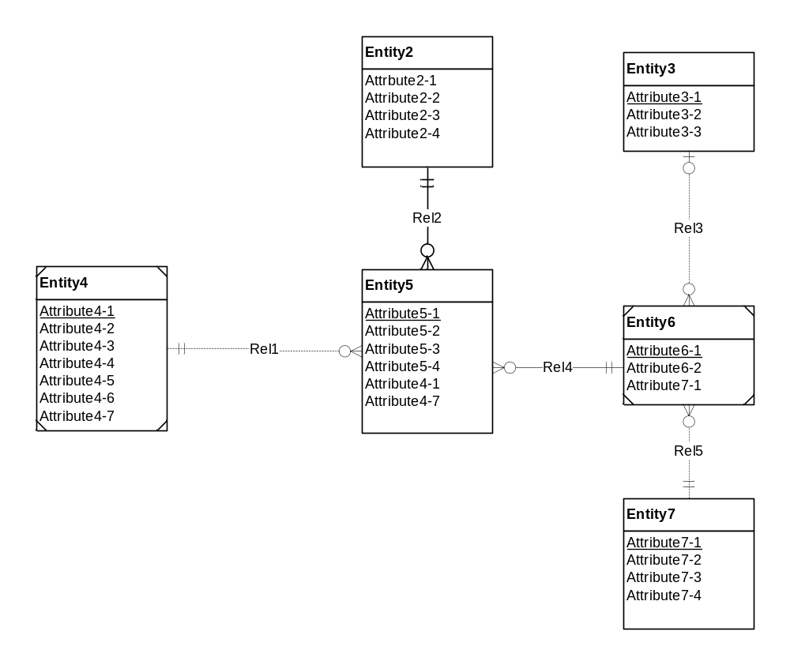
Figure P7: ERD for Problem 6

Violations in the above ERD and Resolutions to solve the violations.
- Primary Key Rule violation in the entity type Entity2 .
Entity types should have atleast one Primary Key.Modifying any one of the attributes in the Entity2 as a primary key will solve the violation.
- Identifying Relationship rule violation for the relationship Rel2.
Identifying Relationship rule says that atleast one participating entity type should be a weak entity type.So modifying anyone of the entity types Entity2 or Entity5 as a weak entity type will solve the error.
- Weak Entity Type Rule Violation for Entity2.
Weak Entity types should have atleast one identifying relationship.So modifying Rel1 as an Identifying relationship will solve the error.
- Redundant Foreign Key Rule violation in Entity5 and Entity6.
Reduntant Foreign Keys should not be used while representing an Entity type in ERD. Removing Attribute4-1 in Entity5 and Attribute7-1 in Entity6 will solve the error.
- Identification Dependency cardinality rule violation in Rel4
Idenifying relationship’s minimum and maximum cardinality must be equal to one from a weak entity.
Reversing the Cardinalities for Rel4 will solve the error.

